How to JAR a Java Project using Eclipse

This document will help you to JAR a java project using the eclipse IDE. JAR stands for Java Archive file. When you JAR a project it allows another user on another computer to run the JAR like it was an applet within a browser so long as that computer has the proper run time environment. There will be projects and programs we will be turning in as JARs in order for me to grade them.
In order to do this, we will use the previous set of notes that built the GraphicsIntro project. It is important to understand that you are JARing up the entire project. So you do not want several other programs in the project. You only want the files that are pertinent to the program being JARed. Here is the project I want to JAR
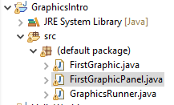
Next you need to right click on the Project you want.

Then you need to left click on Export. When the export window pops up click on Java and you should see the JAR file. Click on Runnable JAR and hit next. See the picture below as a reference
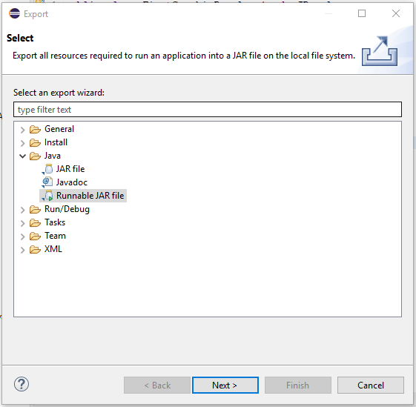
Click on the Runnable JAR file and hit next. You will want to select Launch Configuration and choose the source code with your main method in the Project where you want. In the case of the example it was listed as GraphicsRunner(1) – GraphicsIntro because I have multiple projects with the a main method called GraphicsRunner, but it listed each one with what project it was associated with so that I choose the correct source code. You also should select the destination folder where you would like to save it. Name the JAR file and click finish. You should currently choose Extract required libraries into generated JAR for the time being. See the picture below as a reference.
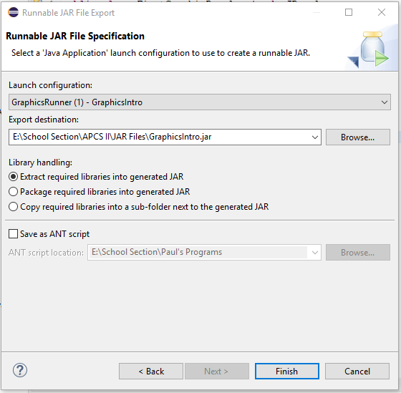
When I JARed this up it gave me a noticed that there were warnings extracted. For the time being lets ignore them.
Once this is done, you can go to file explorer and find the JARed up file. It is listed as an executable JAR file and when you run it, it will run the program.
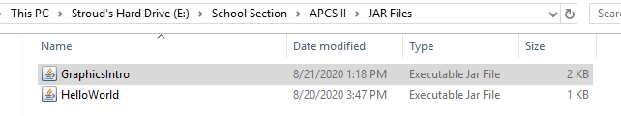
You can now send this JAR file to me though a submission in Canvas for me to grade. It is possible that the JAR files become too large when we are dealing with bigger projects. When that occurs, i would encourage you to place it on google docs and send me a link to it so that I can pull it down on my computer.

